Assignment 2 – Developing a highly available Photo Album website

Ta Quang Tung – 104222196

Tutorial date: Saturday (3 P.M. – 5 P.M.)

Link to photo album website: <http://webserverbalancer-1710659052.us-east-1.elb.amazonaws.com/photoalbum/album.php>

I - Create the VPC and NAT instance

This section lists the steps needed to create and configure the VPC and NAT instance, which fulfils requirements 2.1 and 2.3 of the instructions.

A - Create the VPC

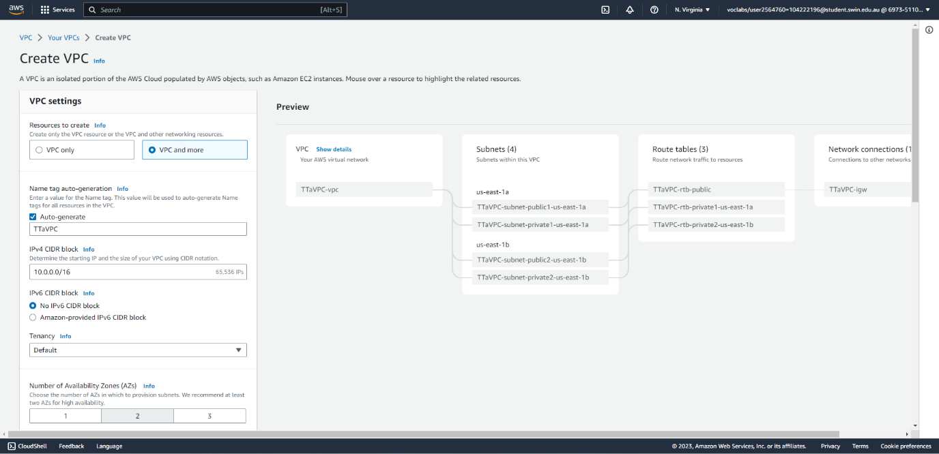



Fig. 1: Create the VPC (part 1/2), specifying its name, CIDR block, and number of AZs.

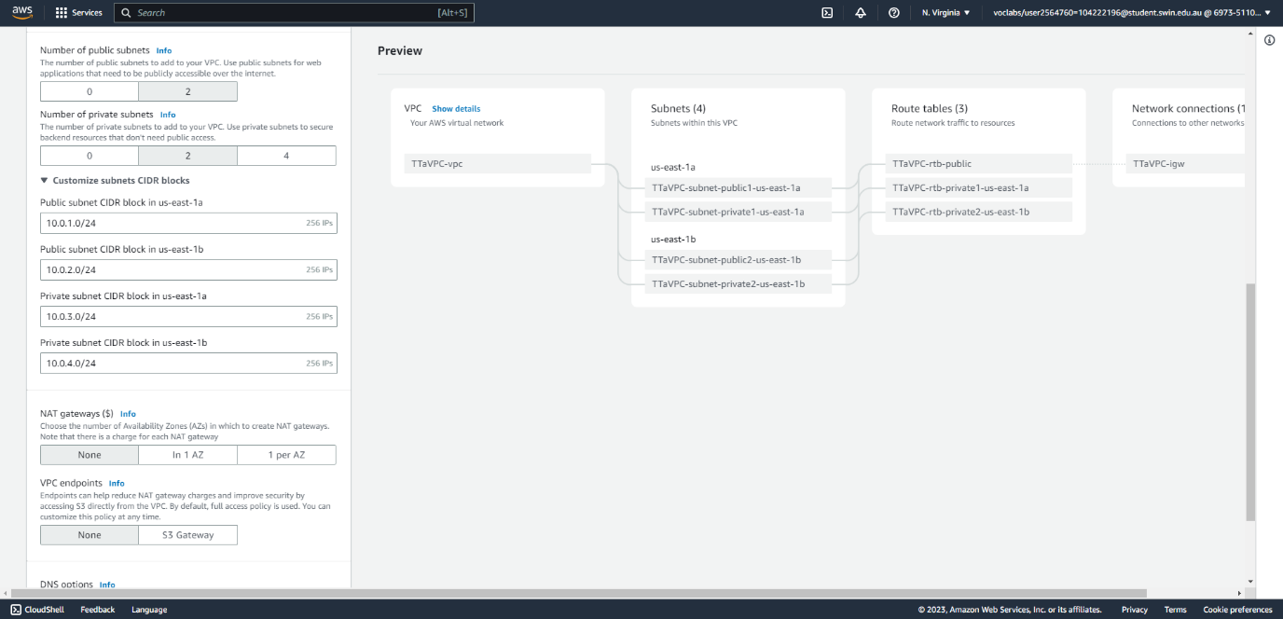



Fig. 2: Create the VPC (part 2/2), specifying the number of private/public subnets per AZ, subnets’ CIDR blocks. The NAT gateway option is unselected because a NAT instance will be created instead.

B – Create the NAT instance

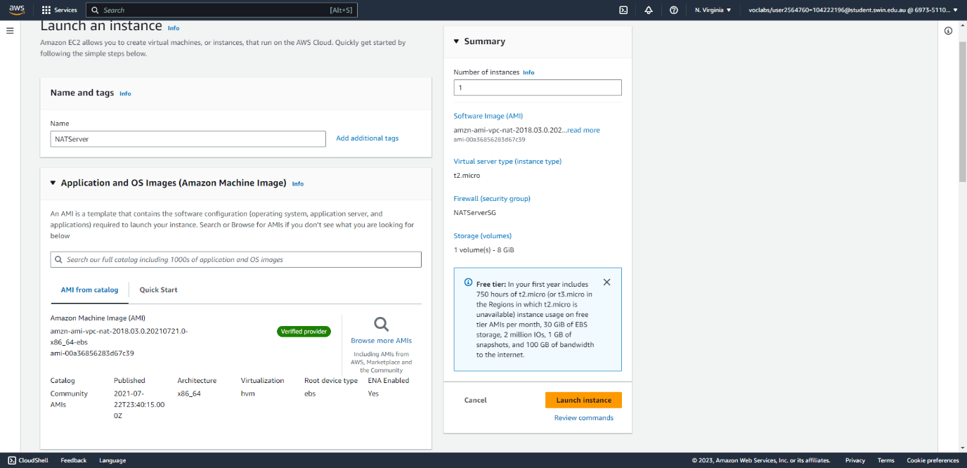



Fig. 3: Create the NAT instance (part 1/3), specifying the name and correct AMI.

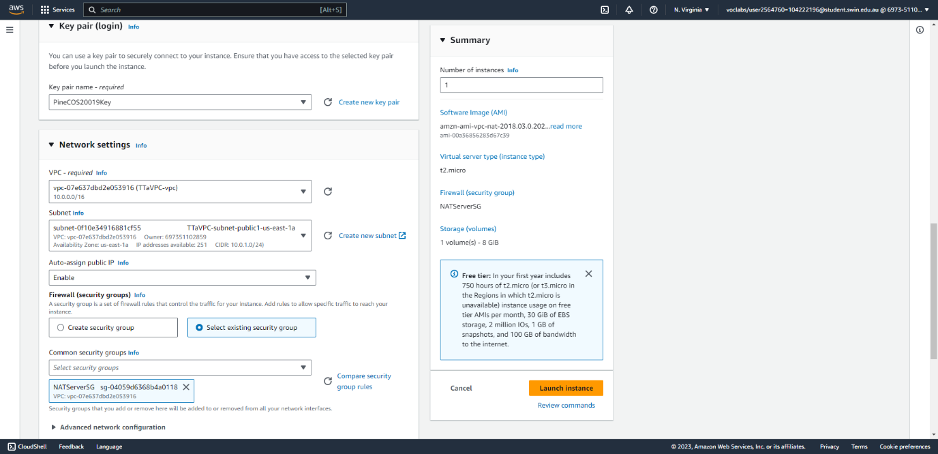



Fig. 4: Create the NAT instance (part 2/3), specifying the key pair and correct network settings.

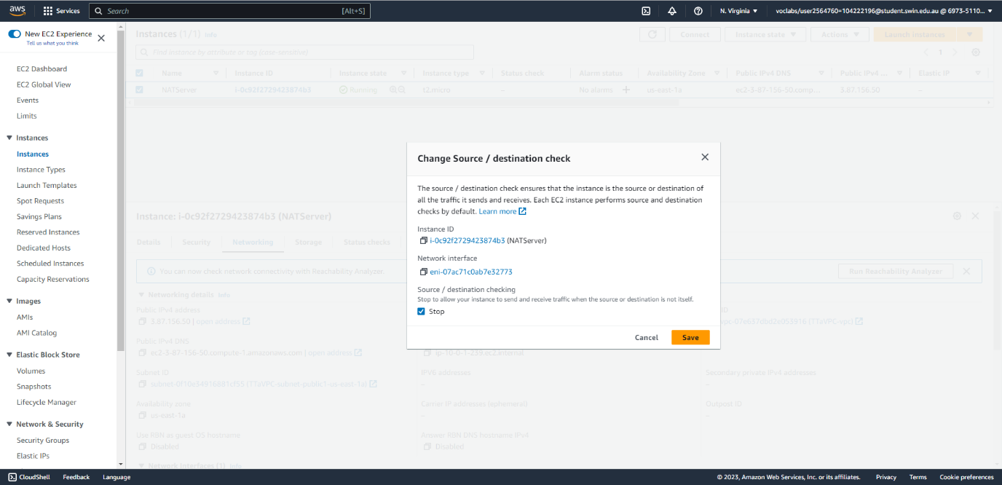



Fig. 5: Create the NAT instance (part 3/3), disabling source/destination check so that the instance can send/receive traffic from other sources/destinations.

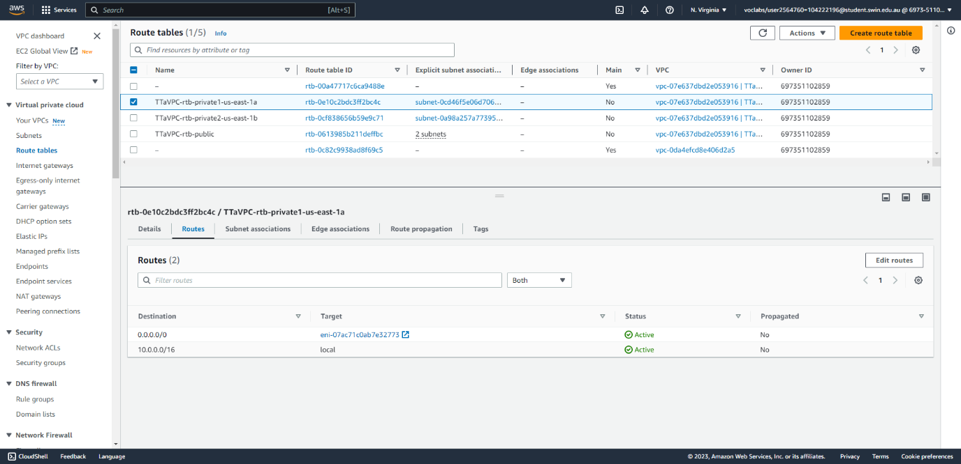



Fig. 6: Create a route on each private route table that directs internet-bound traffic to the NAT instance (1/2).

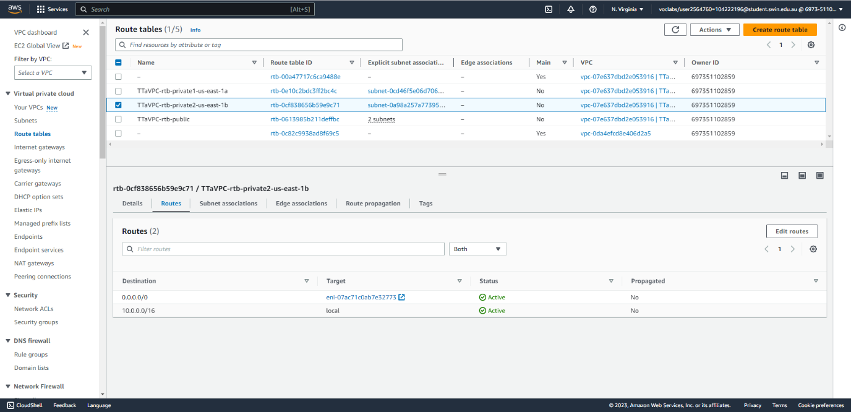



Fig. 7: Create a route on each private route table that directs internet-bound traffic to the NAT instance (2/2).

II - Set up the RDS instance

This section lists the steps needed to create the RDS instance, which fulfils requirement 2.7 in the instructions.

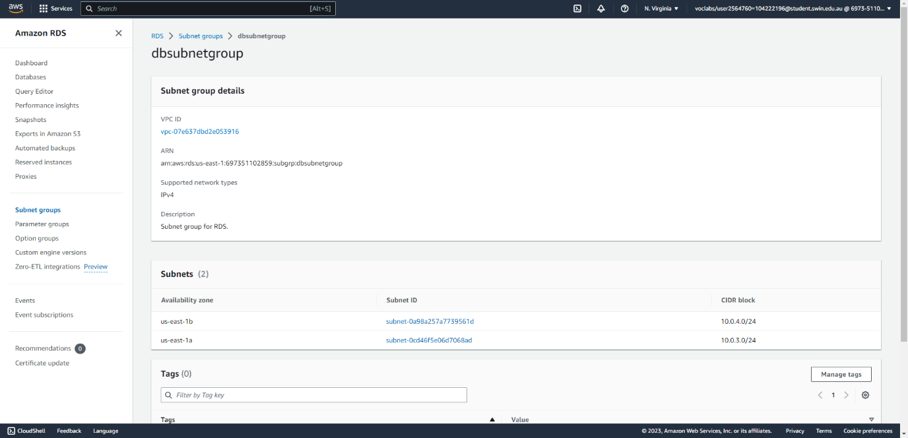



Fig. 8: Create a subnet group for the database instance, specifying the two private subnets of the VPC.

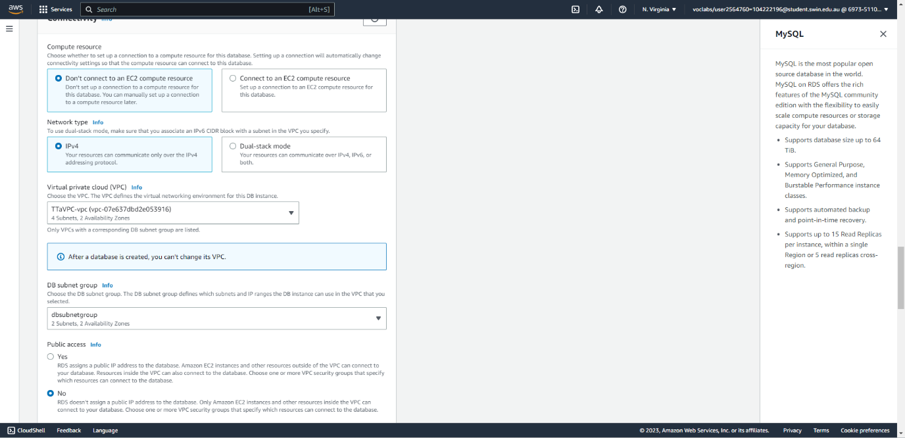



Fig. 9: Create a MySQL database instance similar to Assignment 1B, this time specifying the new VPC and subnet group.

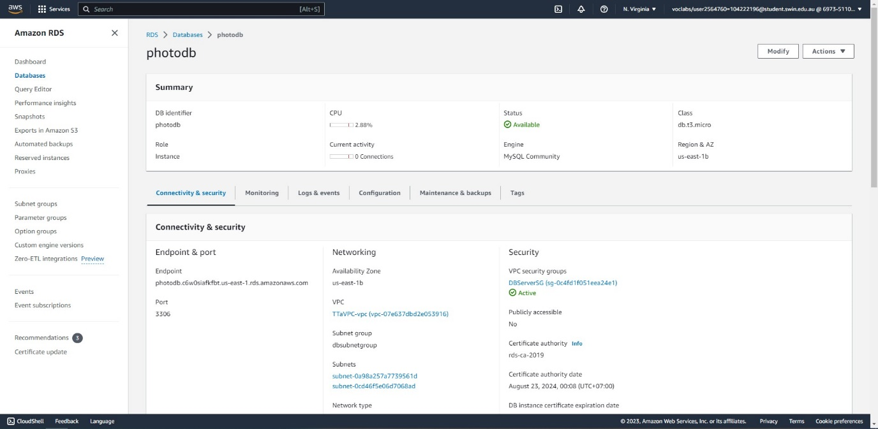



Fig. 10: The database instance has been successfully created. It is using the DBServerSG security group, which will be configured later. The database endpoint will be used to set up the webpage on the development server.

III - Set up the Lambda function

This section lists the steps needed to set up the Lambda function, which fulfils requirement 2.6 in the instructions.

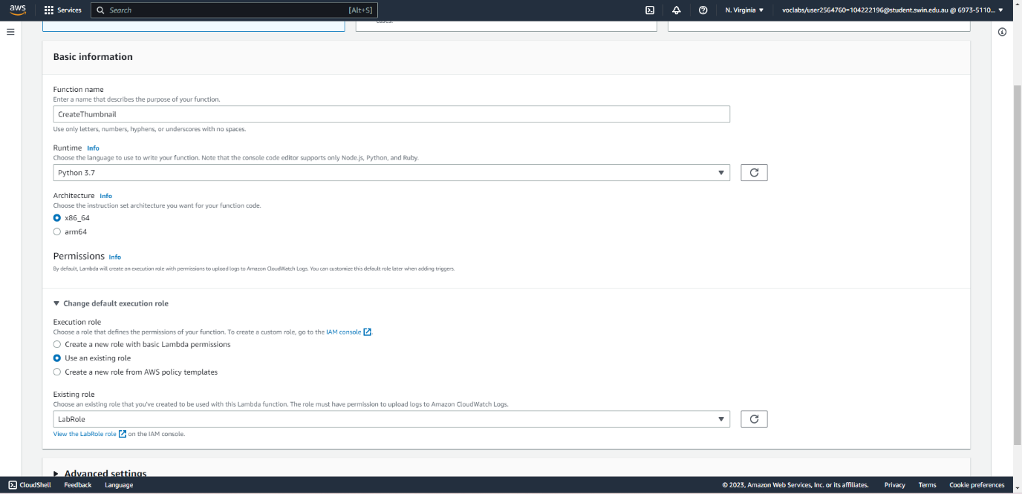



Fig. 11: Create a new Lambda function, specifying its name, runtime language, and IAM role of LabRole.

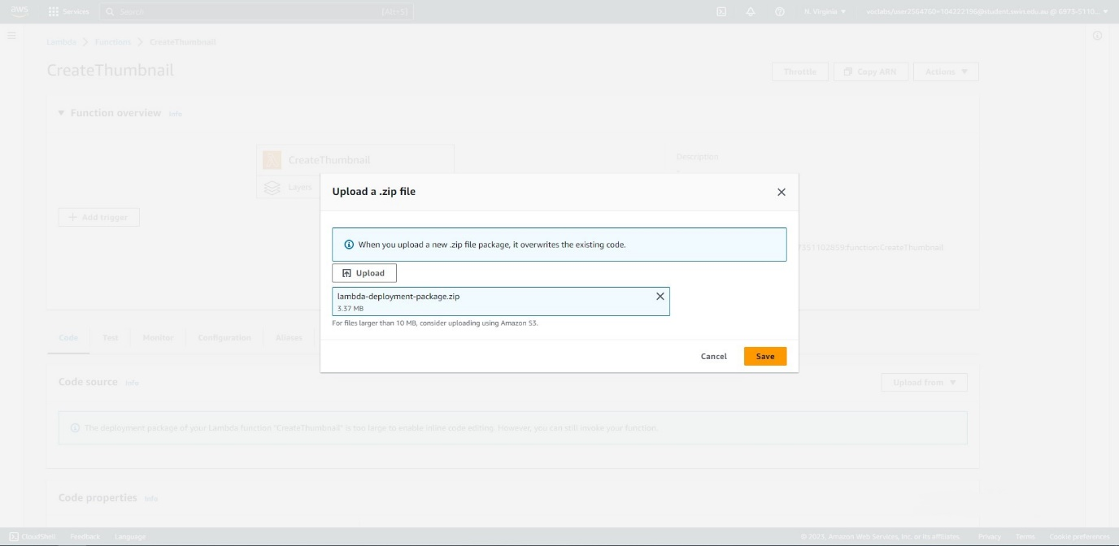



Fig. 12: Upload the .zip file containing the code for the Lambda function.

IV - Set up the S3 bucket

This section lists the steps needed to set up the S3 bucket for photo storage, which fulfils requirement 2.2 in the instructions.

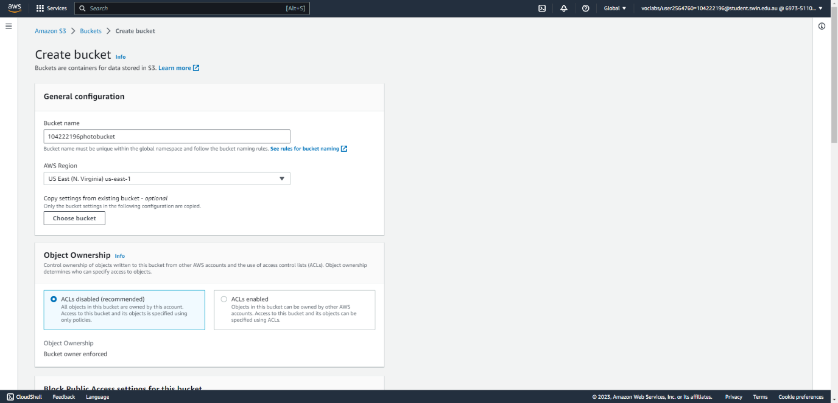



Fig. 13: Create a new S3 bucket (part 1/2), specifying its name, region, and object ownership settings.

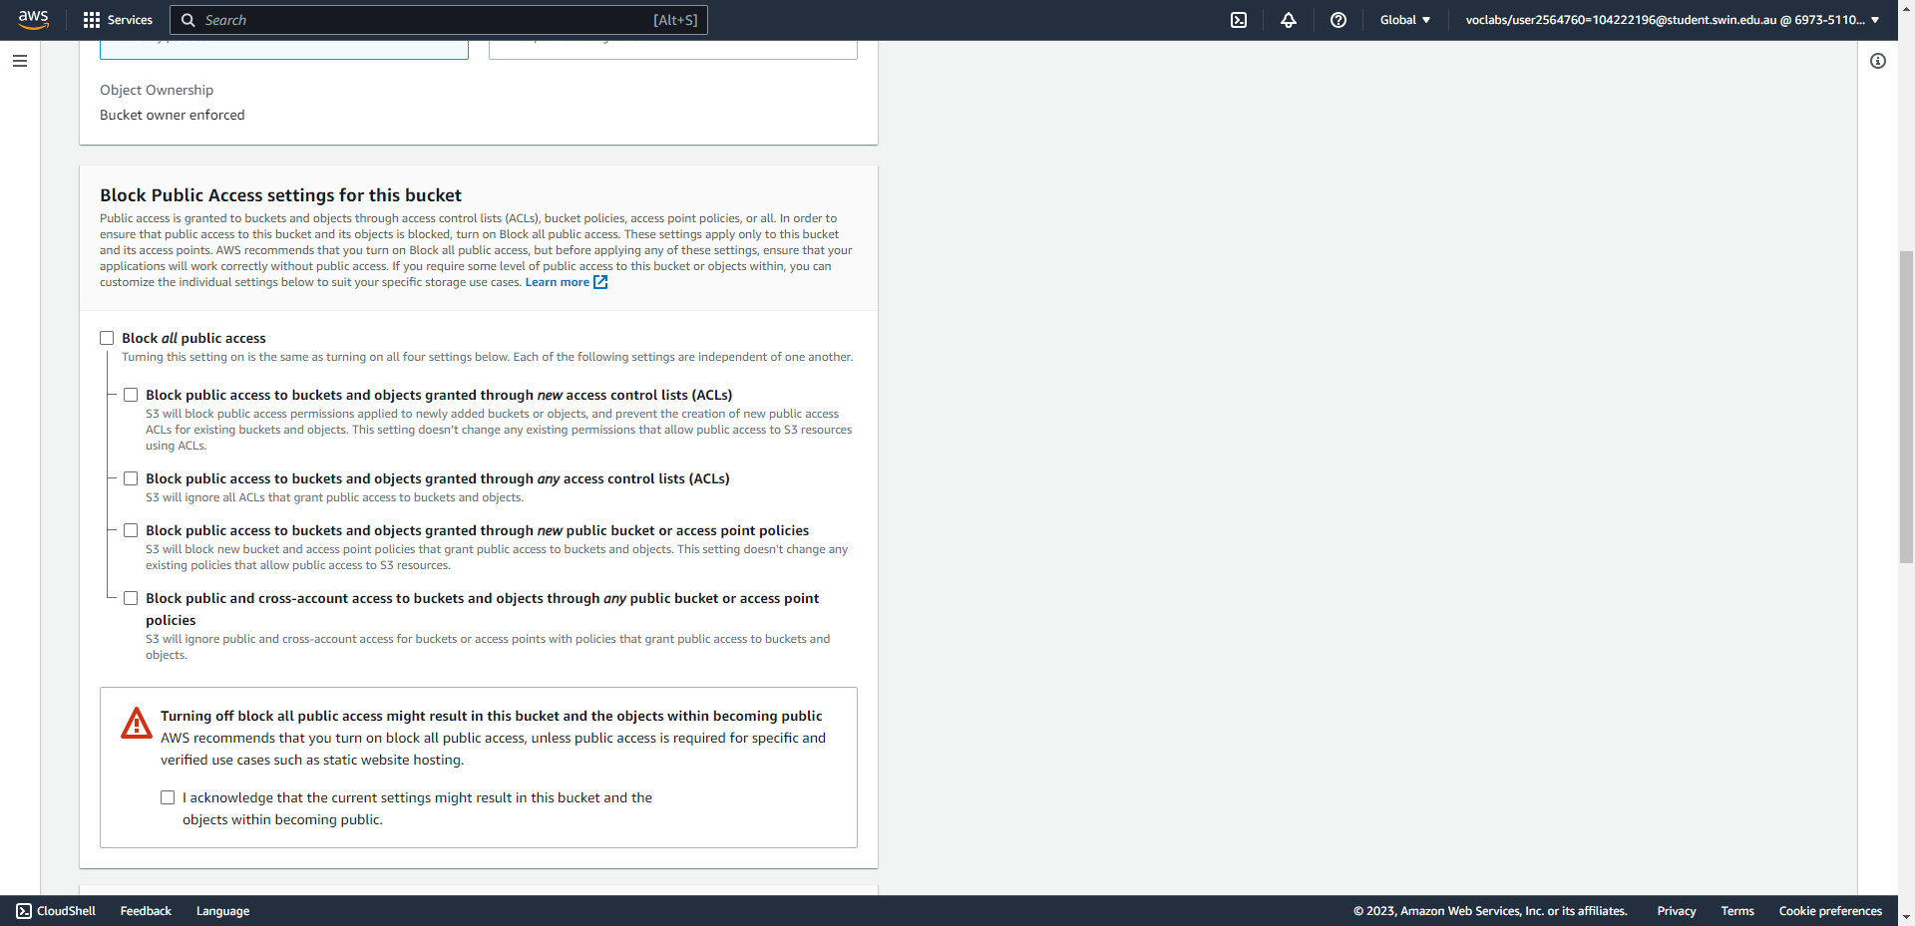



Fig. 14: Create a new S3 bucket (part 2/2), opening all public access to the bucket.

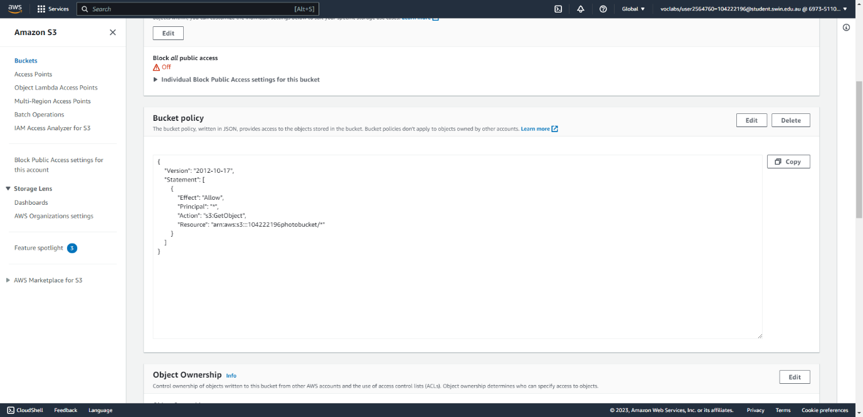

Fig. 15: Specify an access policy for the bucket, which at the moment allows all objects to be publicly retrieved. This policy will be tightened later.

V - Set up the Dev Server

This section lists the steps needed to configure the Development Server instance, which will be used to create the AMI from which new Web Server instances will be launched. This step fulfils requirement 2.5 in the instructions.

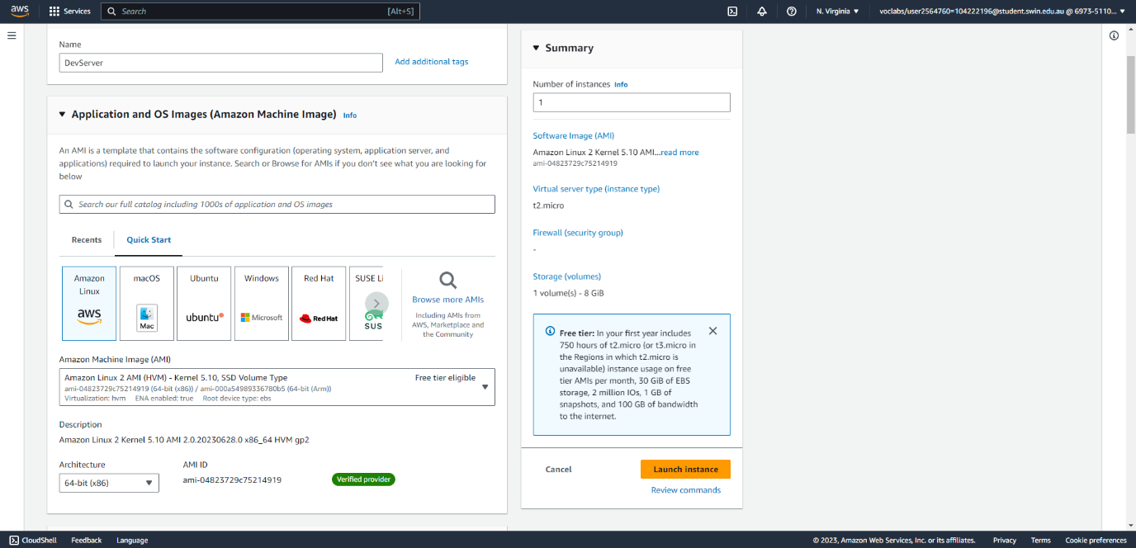



Fig. 16: Create a new EC2 instance for the Dev Server (part 1/3), specifying the name and correct AMI.

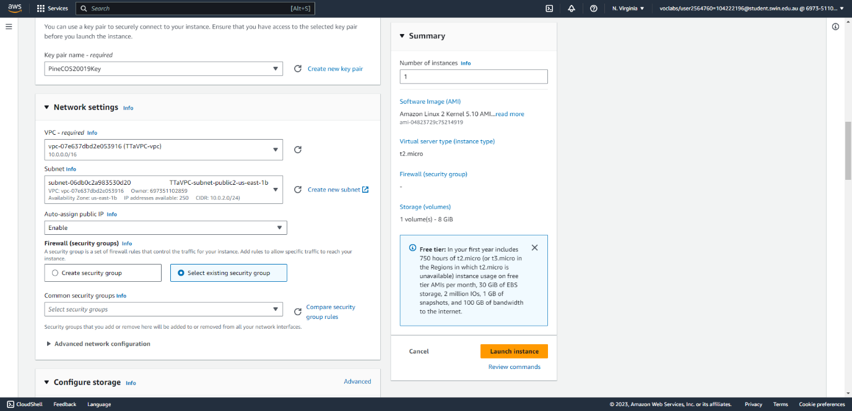



Fig. 17: Create a new EC2 instance for the Dev Server (part 2/3), specifying the key pair, VPC, subnet, public IP, and security group (which is currently empty)

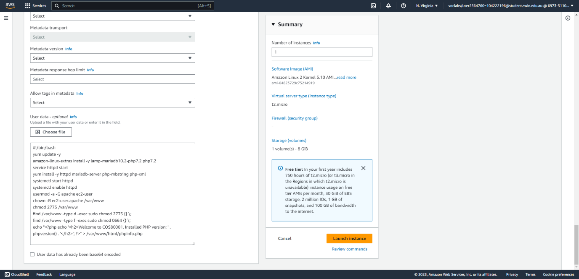



Fig. 18: Create a new EC2 instance for the Dev Server (part 3/3), specifying the user data script to install Apache server.

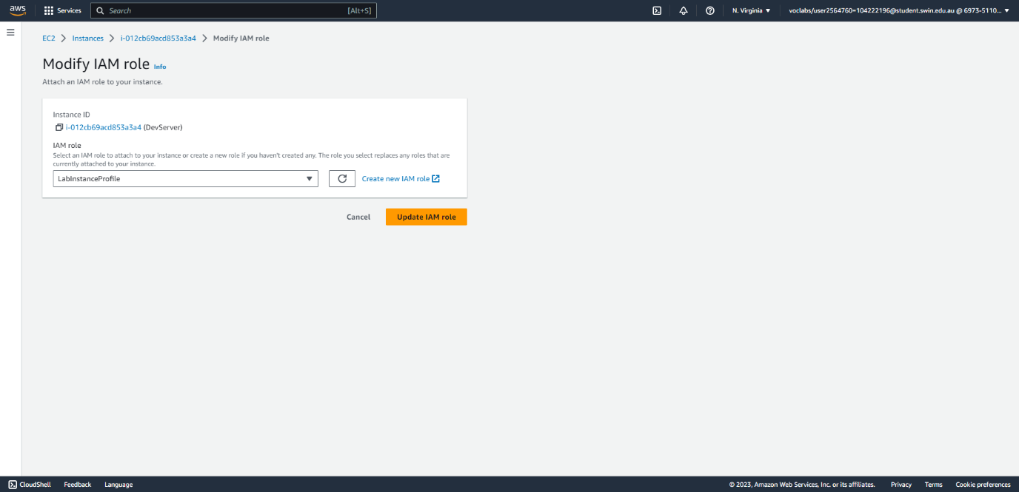



Fig. 19: Assign the correct IAM role to the Dev Server instance so that it can call AWS resources.

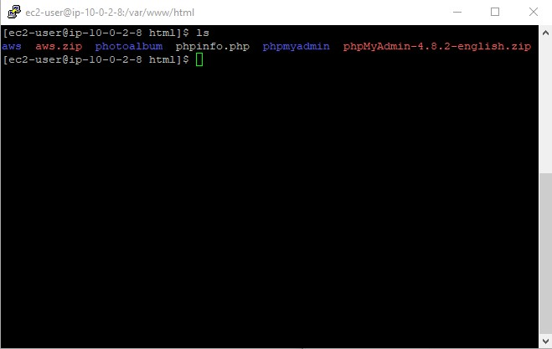



Fig. 20: SSH into the Dev Server and install the PHPMyAdmin package to configure the database instance as well as the AWS SDK to interact with AWS services through PHP code.

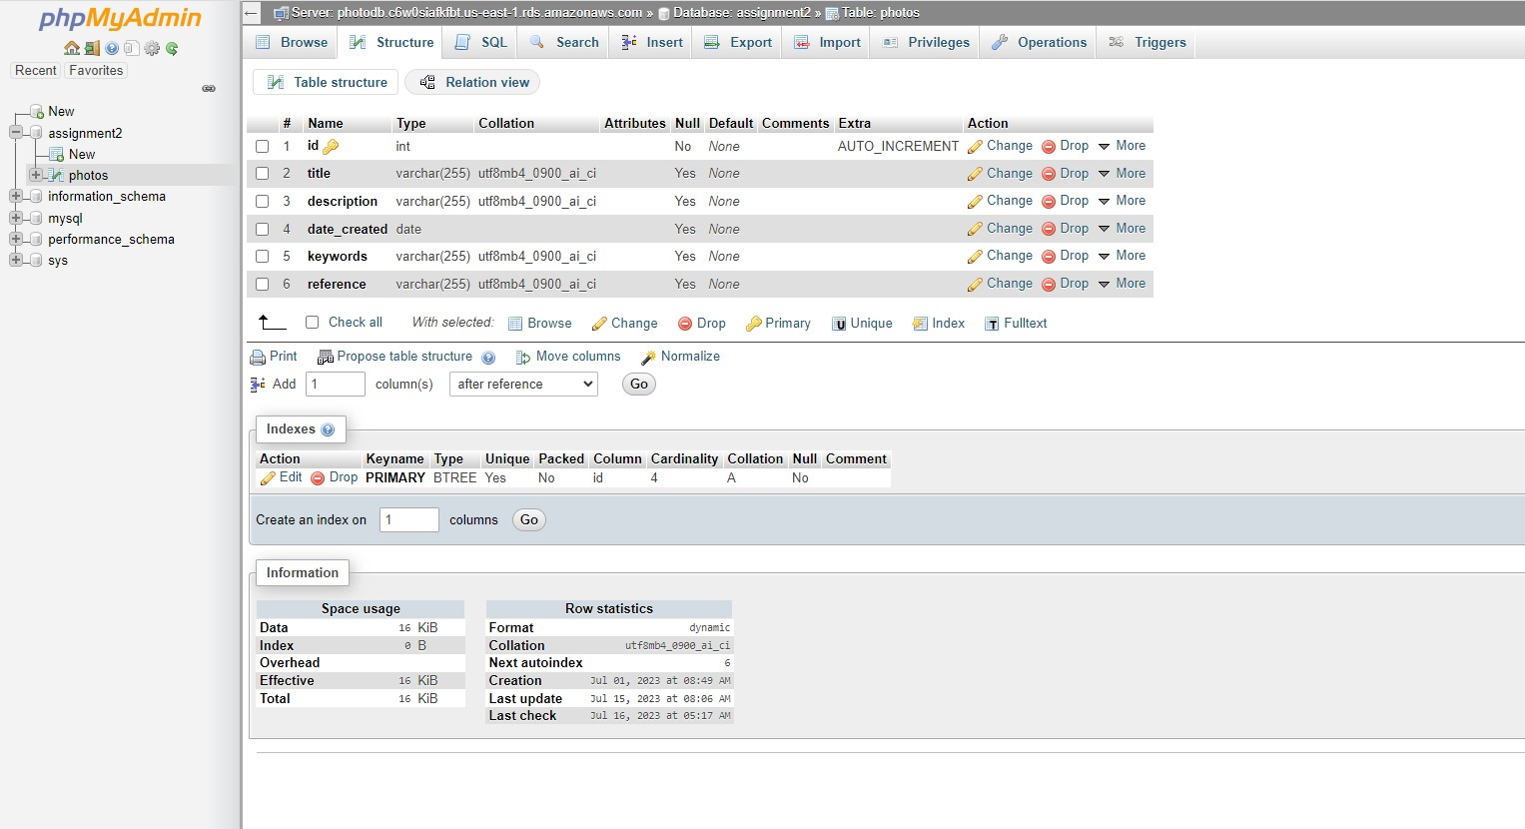



Fig. 21: After configuring PHPMyAdmin similar to Assignment 1B, access the database instance and create a table to store the necessary data.

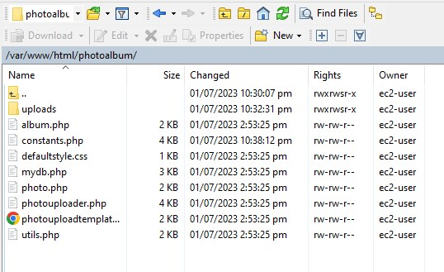



Fig. 22: After the database table, S3 bucket, and Lambda function have been set up, modify the contants.php file in the souce code and upload everything to the correct directory on Dev Server through WinSCP.

VI - Create the target group, ELB, and auto-scaling group

This section lists the steps needed to create the load balancer and auto-scaling group (ASG), which fulfils requirements 2.3 and 2.4 in the instructions.

A – Create the target group

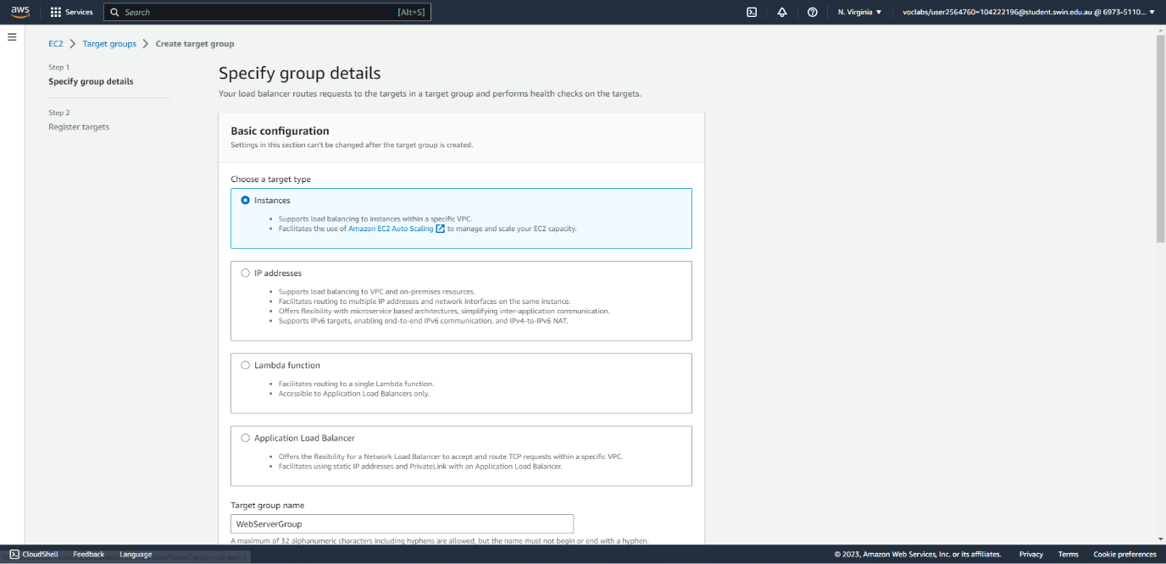



Fig. 23: Create a new target group (part 1/3), setting the type of target as Instances.

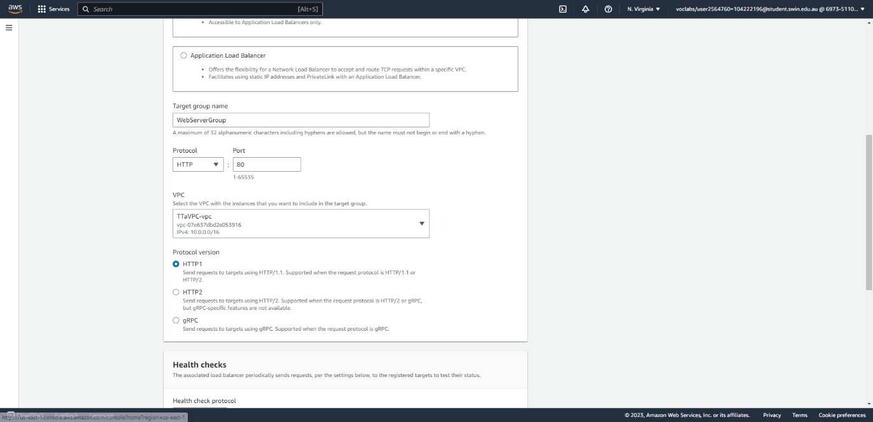



Fig. 24: Create a new target group (part 2/3), specifying the name, protocol, and VPC.

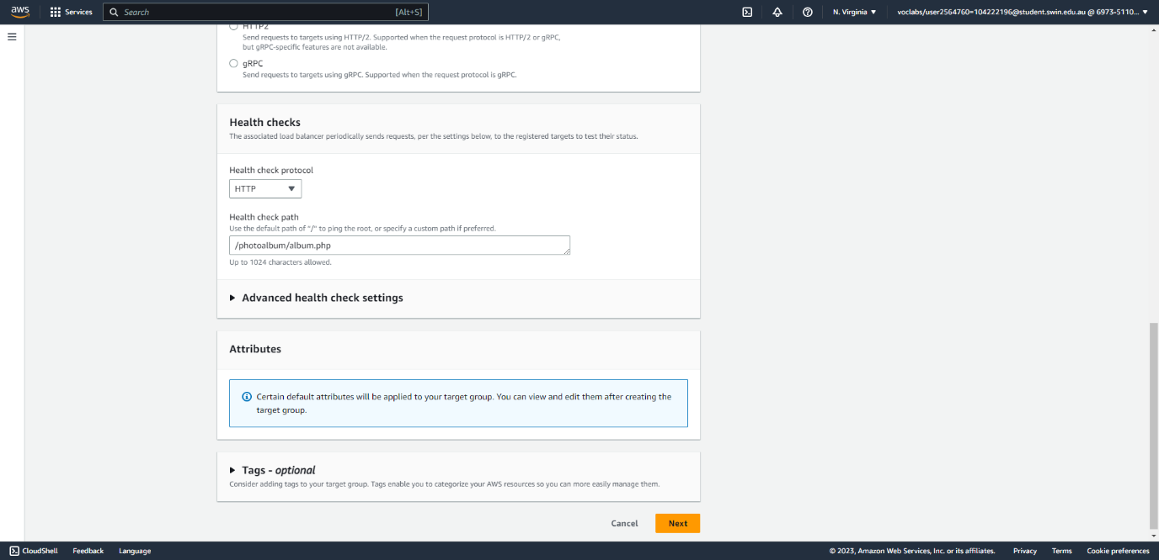



Fig. 25: Create a new target group (part 3/3), specifying the health check settings.

B – Create the Application Load Balancer

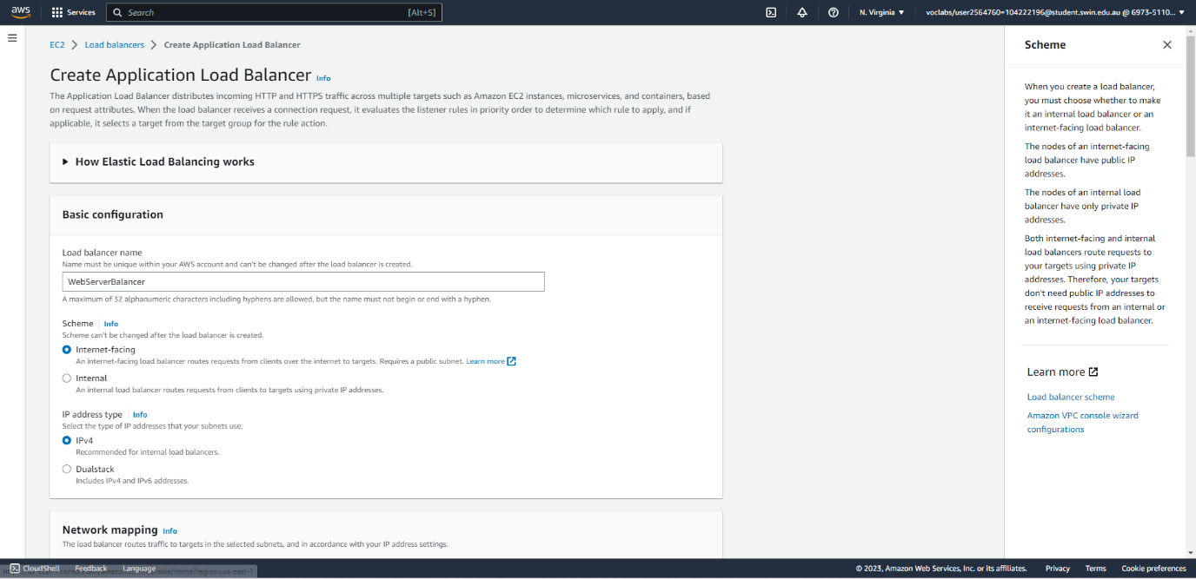



Fig. 26: Create an application load balancer (part 1/3), specifying the name and scheme.

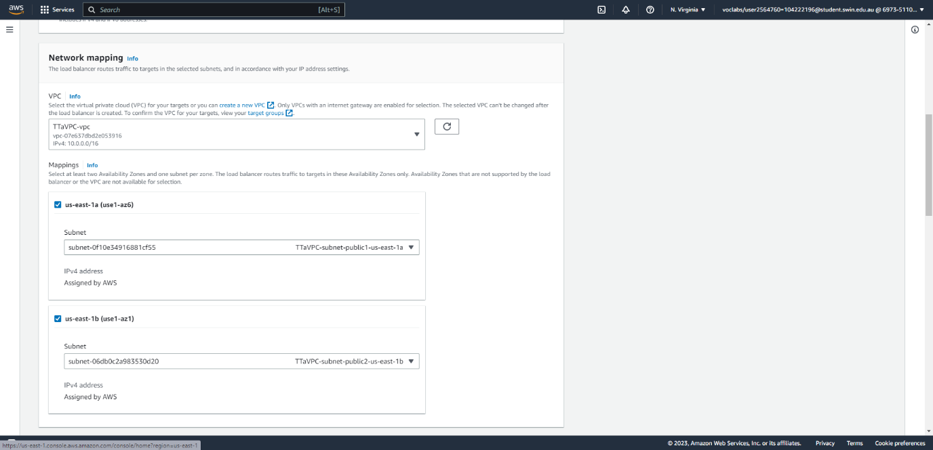



Fig. 27: Create an application load balancer (part 2/3), specifying the VPC and public subnets.

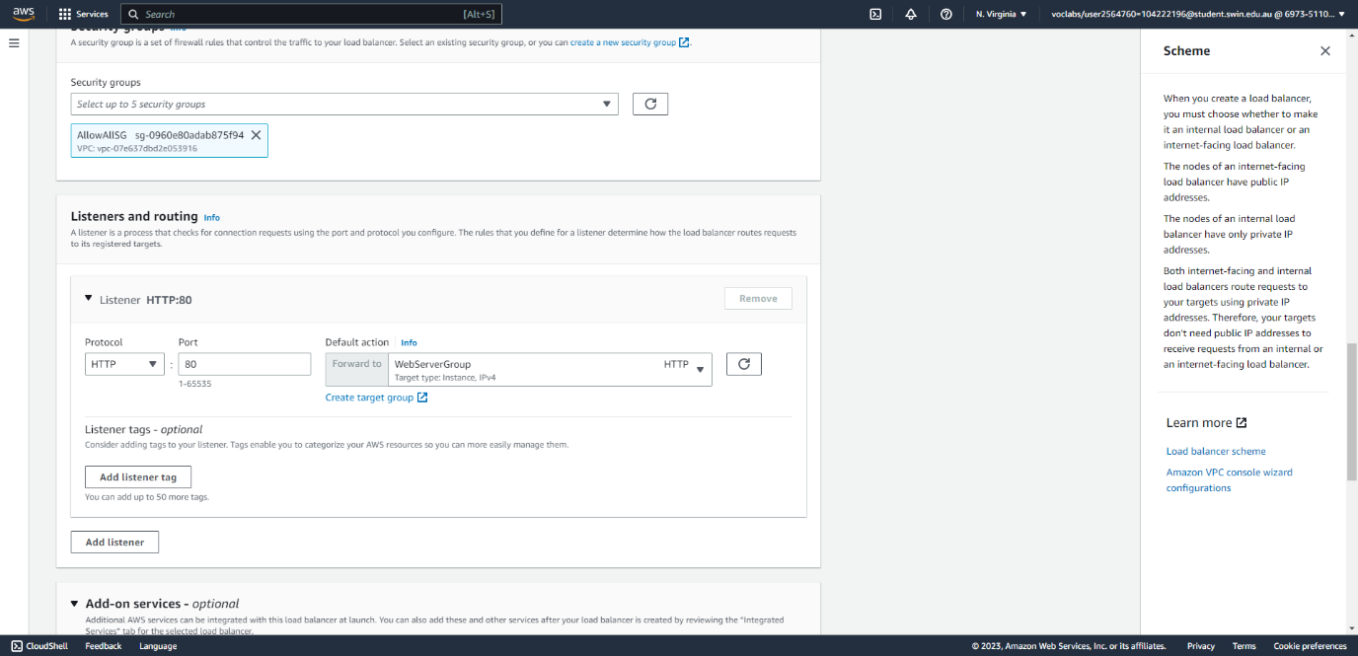



Fig. 28: Create an application load balancer (part 3/3), specifying the security group (which currently allows all inbound traffic) and listener.

C – Create the Auto-scaling Group

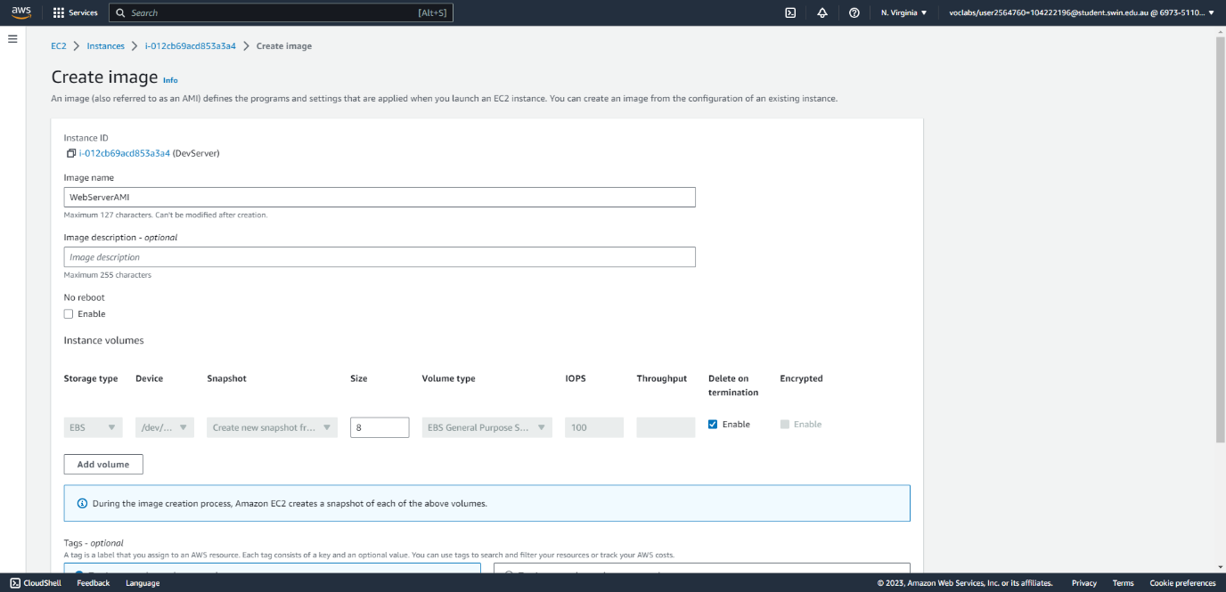



Fig. 29: Create an AMI from the Dev Server instance.

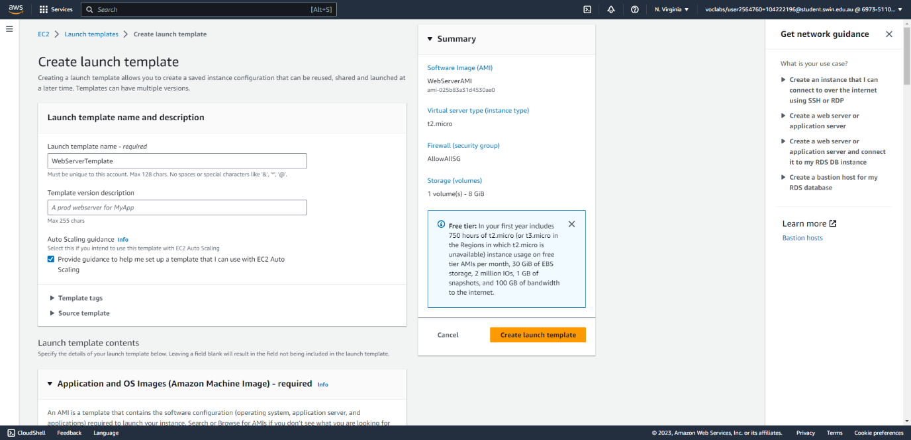



Fig. 30: Create a launch template using the Dev Server AMI (part 1/3), specifying the name and selecting “provide guidance for auto-scaling”.

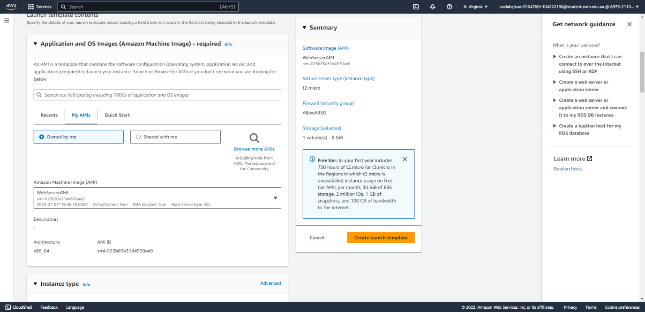



Fig. 31: Create a launch template using the Dev Server AMI (part 2/3), selecting the correct AMI.

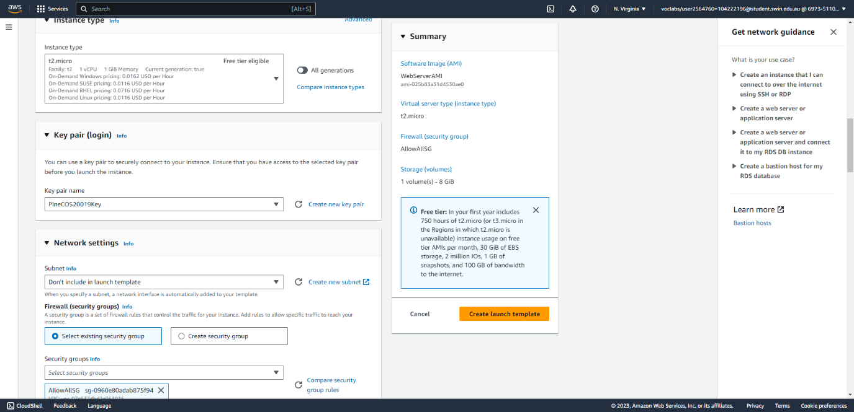



Fig. 32: Create a launch template using the Dev Server AMI (part 3/3), selecting the key pair and security group (which currently allows all traffic in and out; however, the correct security group will be assigned later, resulting in a new version of the launch template.)

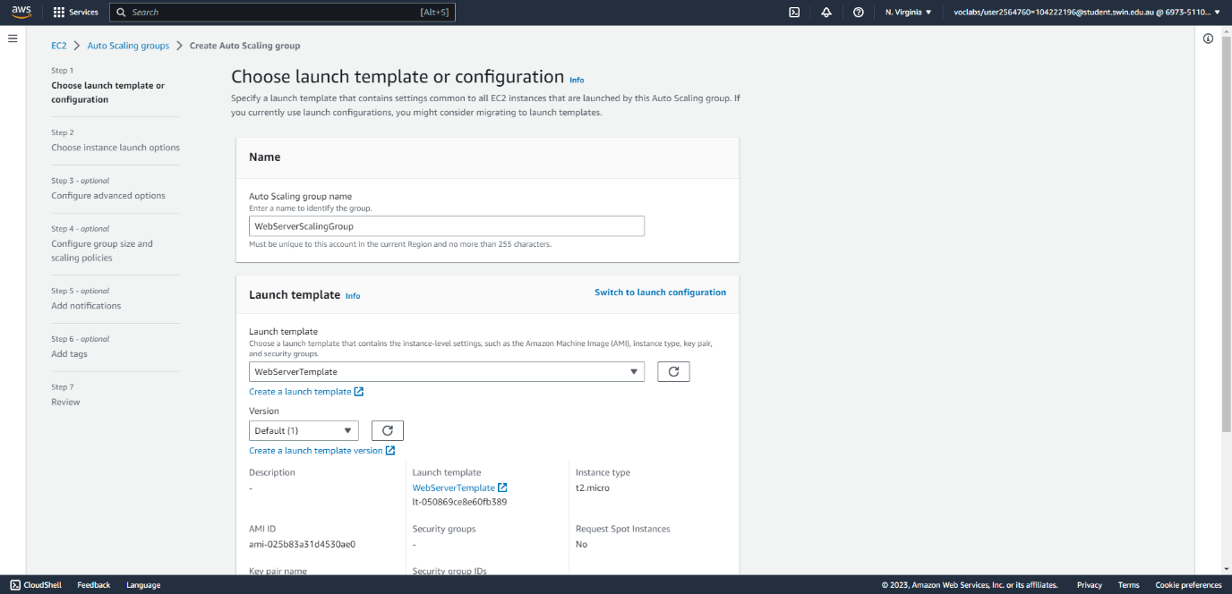



Fig. 32: Create an auto scaling group from the launch template (part 1/5): giving a name, selecting the correct launch template (Currently the ASG uses the version of the launch template without the correct security group. This will be corrected later.)

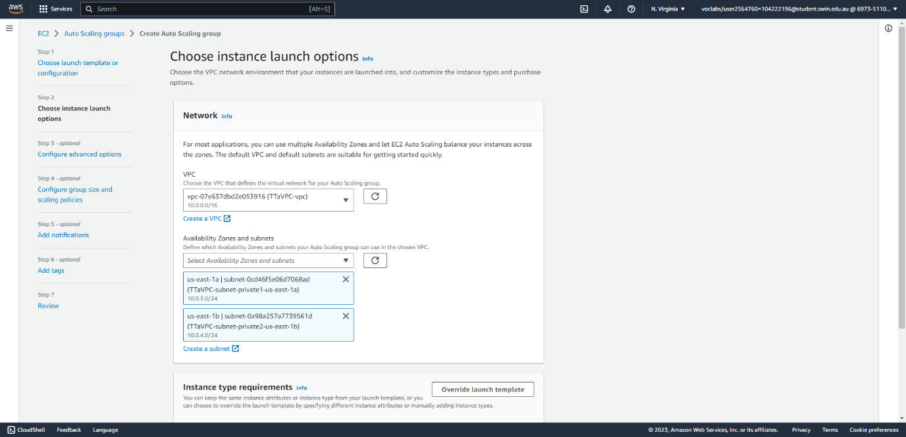



Fig. 33: Create an auto scaling group from the launch template (part 2/5): selecting the correct VPC and private subnets.

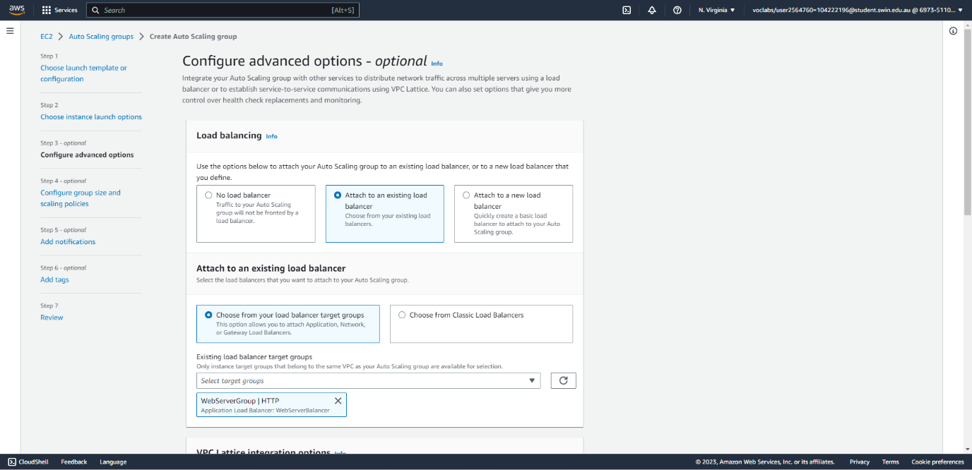



Fig. 34: Create an auto scaling group from the launch template (part 3/5): attaching it to the Web Server target group created earlier.

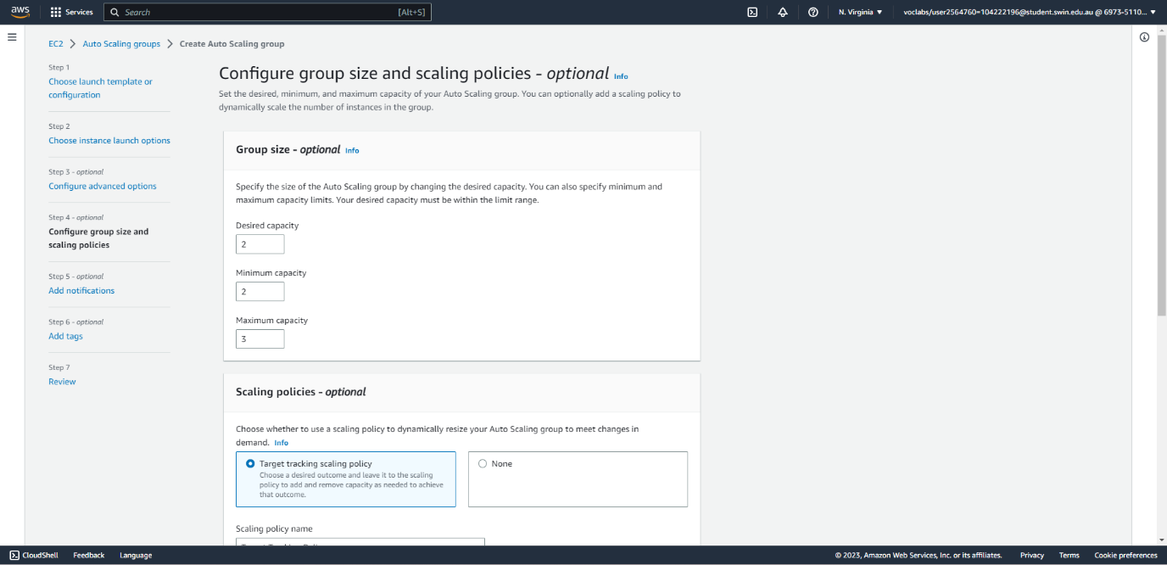



Fig. 35: Create an auto-scaling group from the launch template (part 4/5): setting the group size.

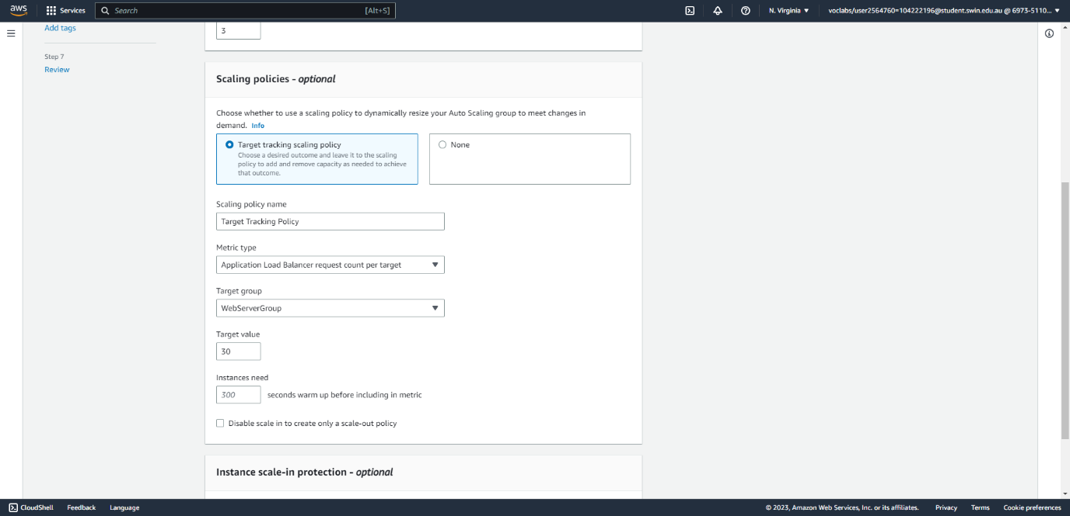



Fig. 36: Create an auto scaling group from the launch template (part 5/5): defining a scaling policy to keep the request count per target at 30.

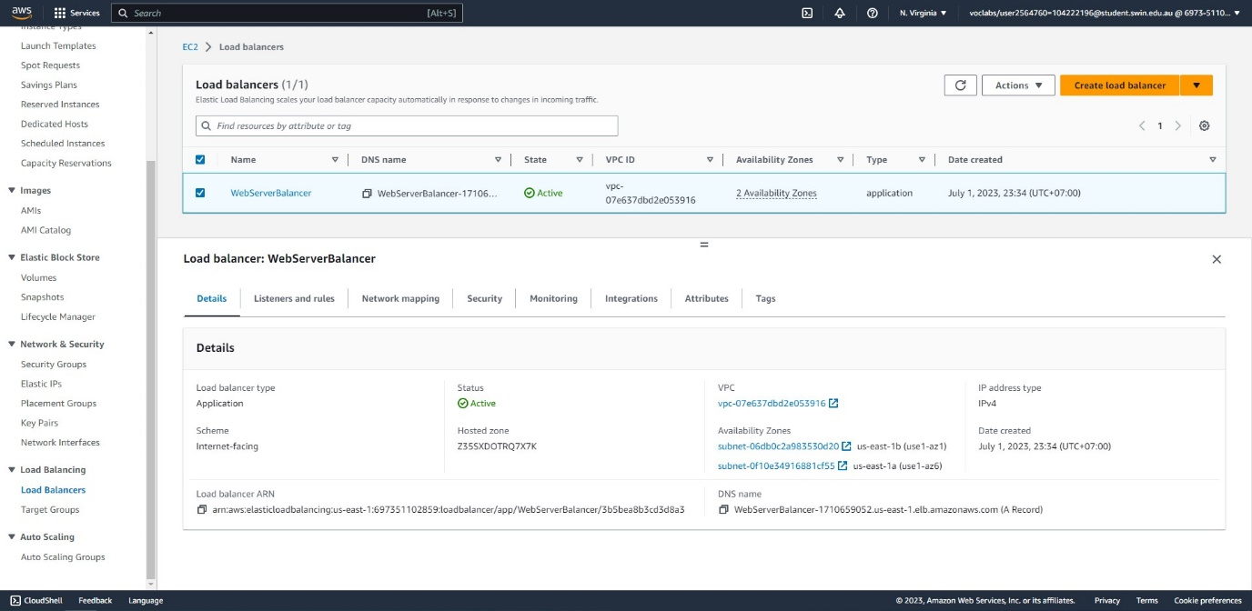

Fig. 37: The load balancer successfully created.

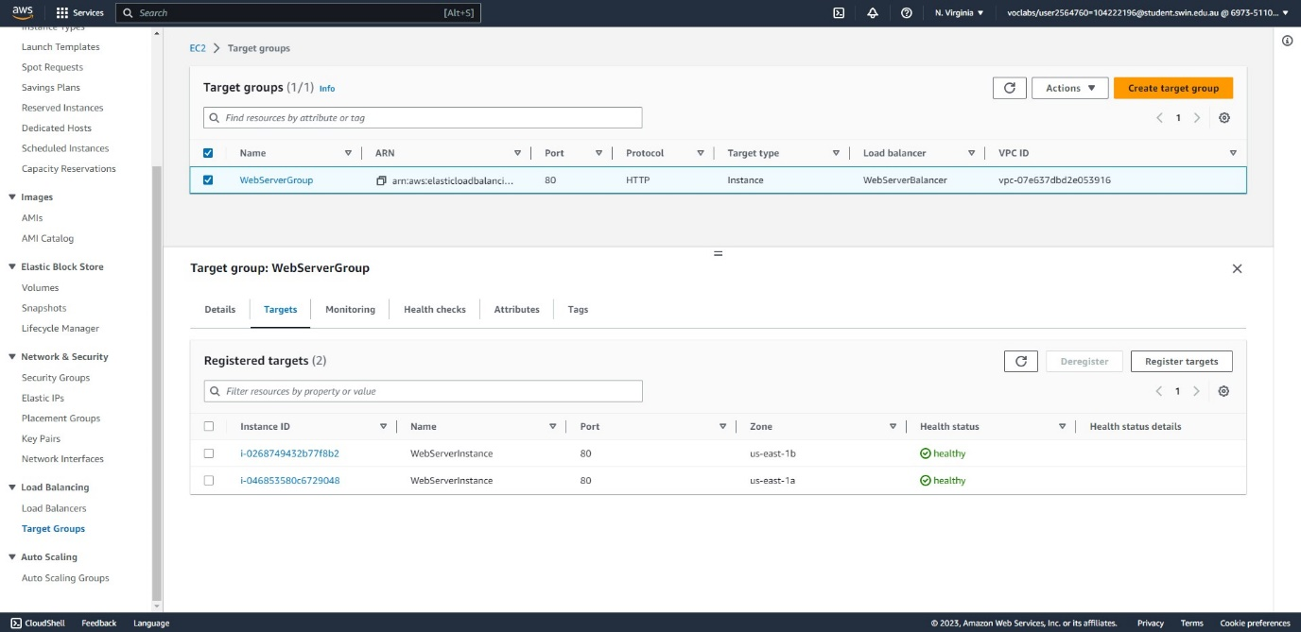



Fig. 38: The target group successfully created with two healthy instances launched by the ASG.

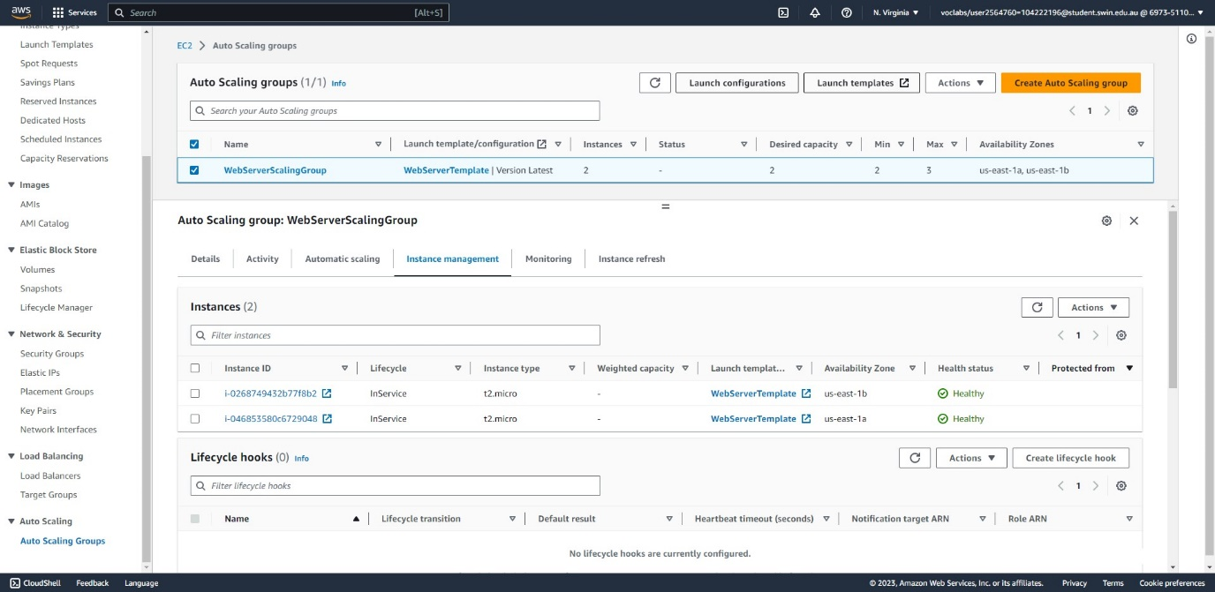



Fig. 39: The auto scaling group successfully created with two healthy instances.

VII - Create security groups, NACLs, and specify bucket policies

This section lists the steps needed to create the security groups and NACLs, which fulfils requirements 2.8 and 2.9 in the instructions. This section also completes the bucket policy to block access to photos outside the website.

A – Create security groups

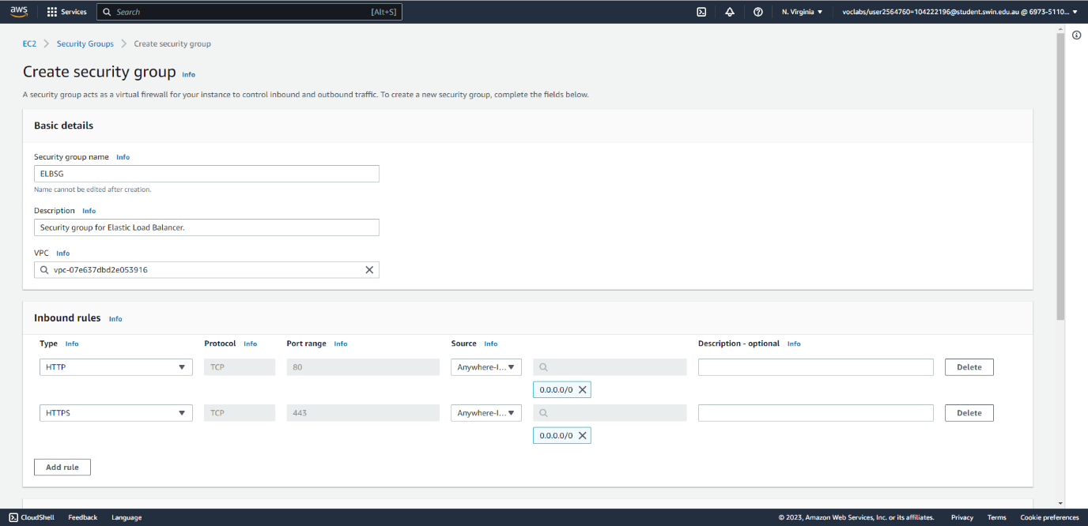

Fig. 40: Create the security group for the ELB allowing inbound HTTP(S) traffic from the Internet.

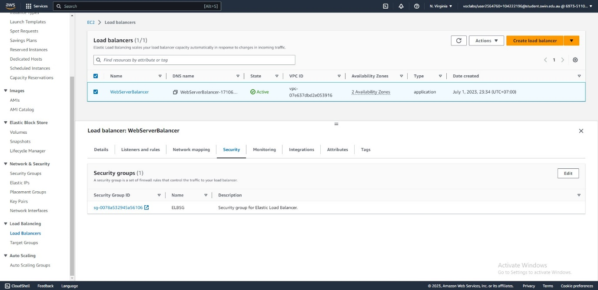



Fig. 41: Associate the security group with the ELB.

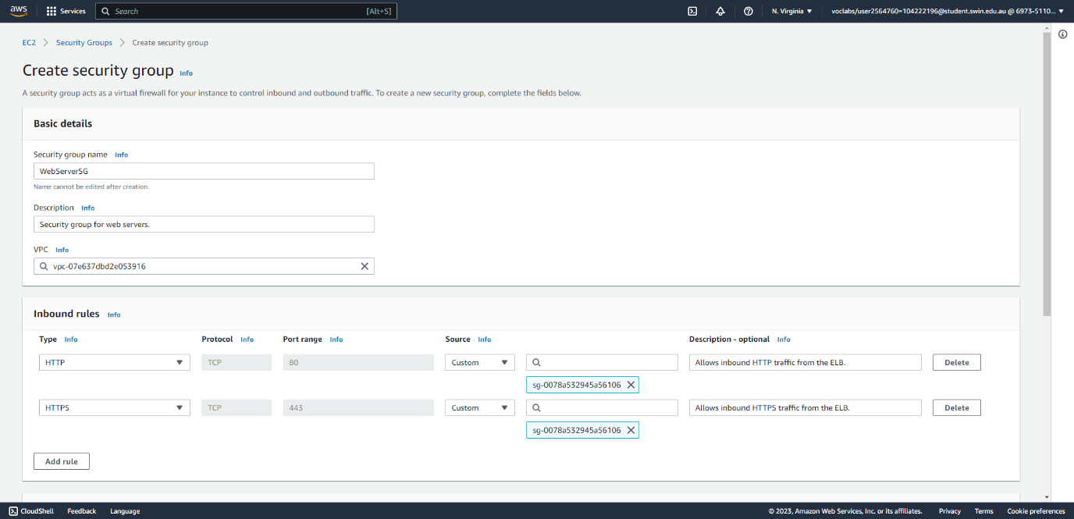

Fig. 42: Create a security group for the web server instances allowing all HTTP(S) traffic from the ELB.

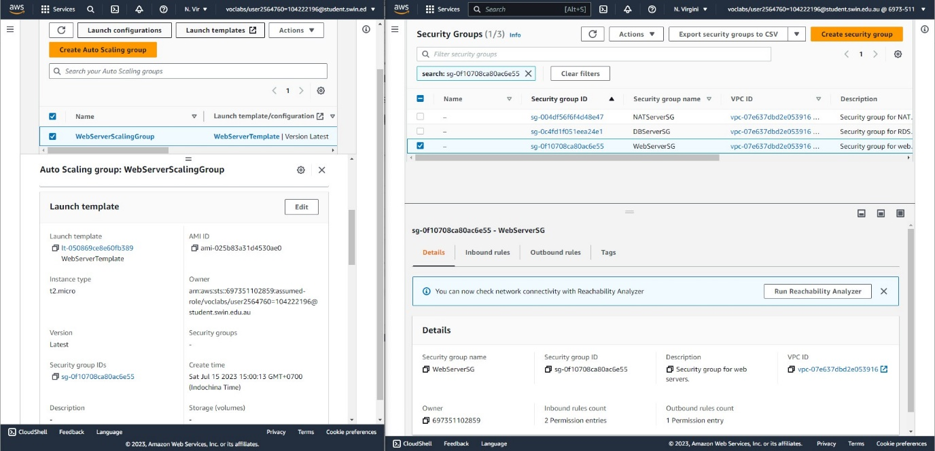



Fig. 43: A new version of the launch template has been created to include the new Web Server security group. The ASG has been reconfigured to use the latest version of the launch template, which contains the correct security group. All old instances of the ASG have been terminated and recreated to include this change.

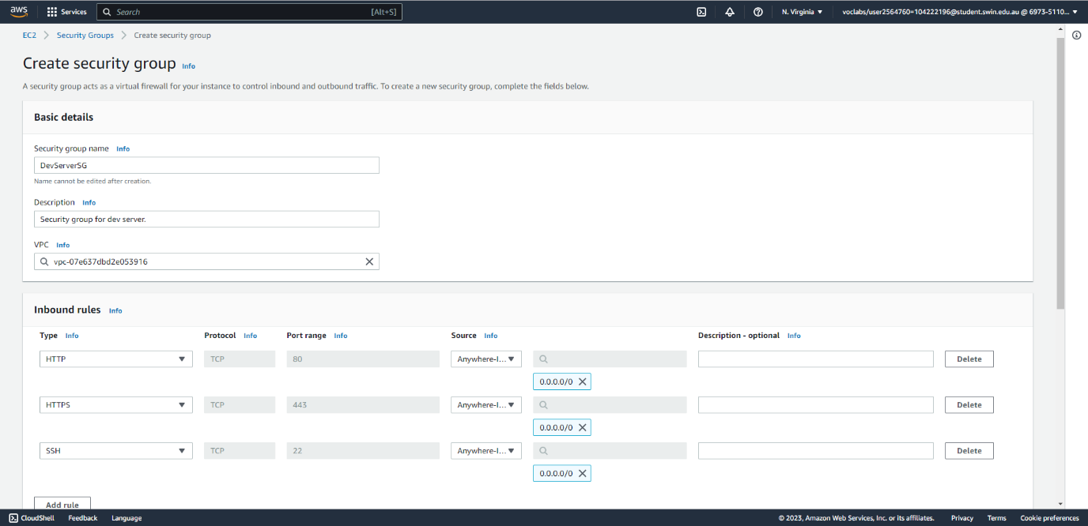

Fig. 44: Create a new security group for the Dev Server allowing all inbound HTTP(S) and SSH traffic from the Internet.

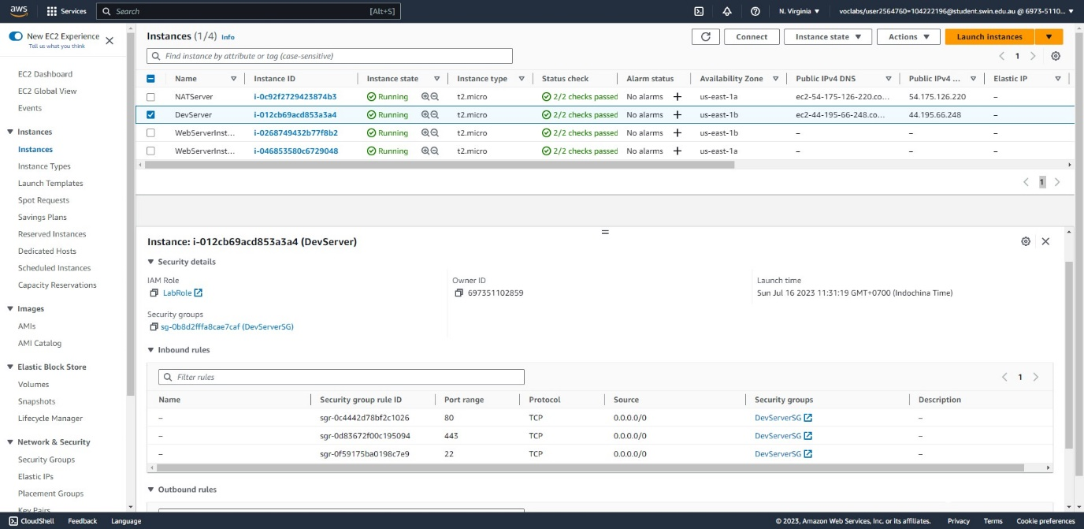



Fig. 45: Assign the security group to the Dev Server.

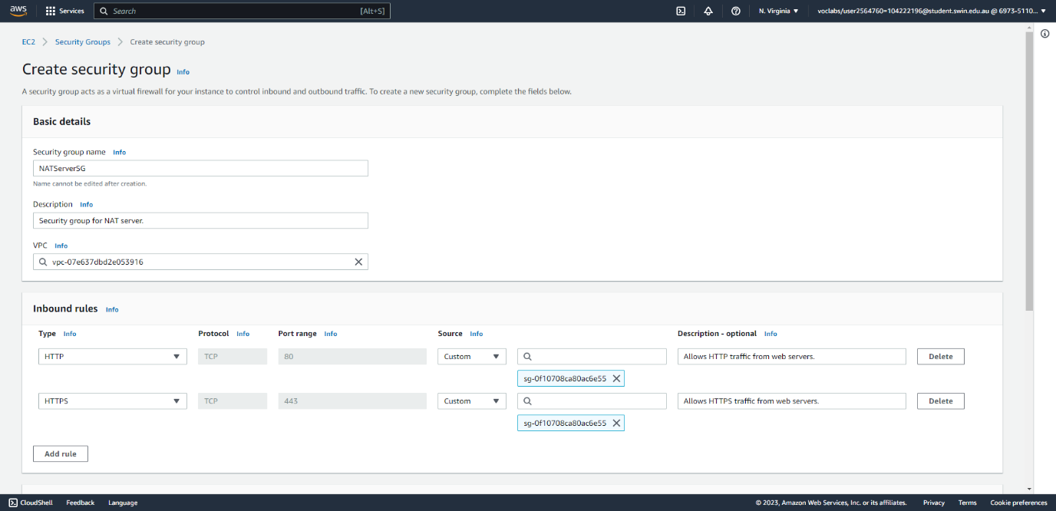

Fig. 46: Create a new security group for the NAT server allowing all inbound HTTP(S) traffic from the web server instances.

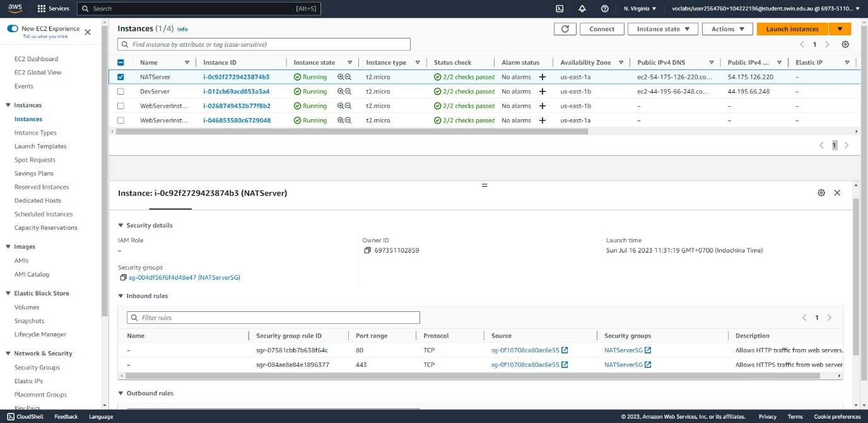



Fig. 47: Assign the security group to the NAT server.

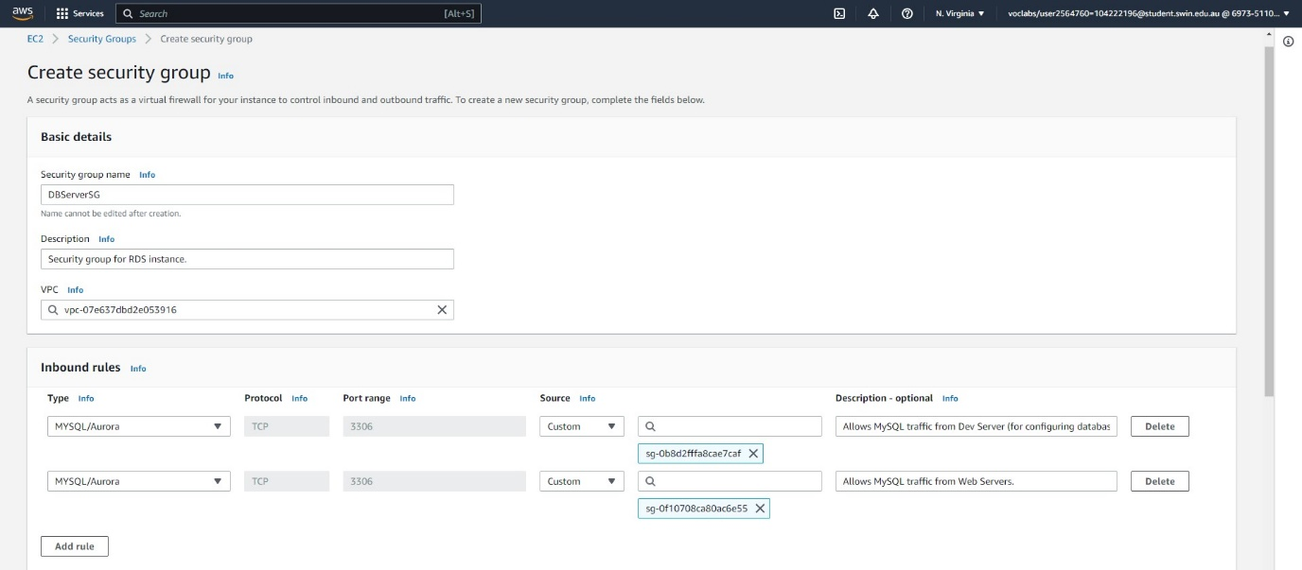

Fig. 48: Create a security group for the database instance allowing inbound MySQL traffic from the Dev and Web server instances.





Fig. 49: Assign the security group to the DB instance.

B – Create the NACL

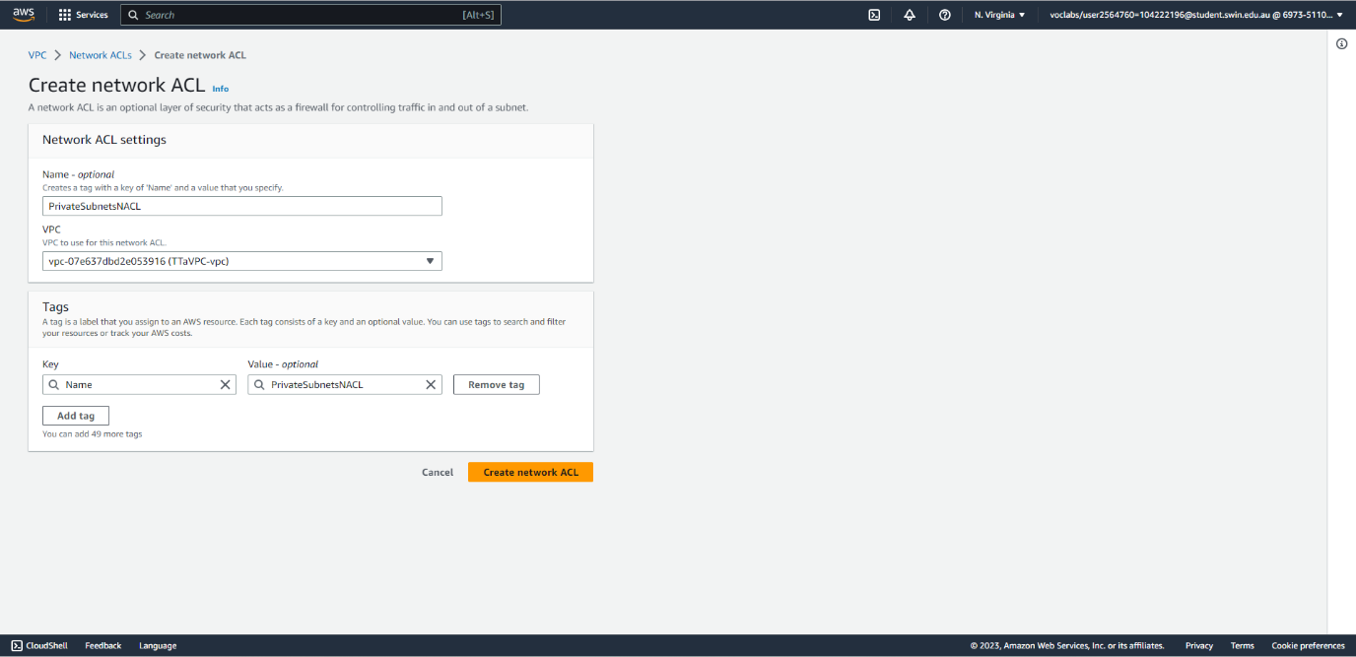

Fig. 50: Create a network ACL for the two private subnets.

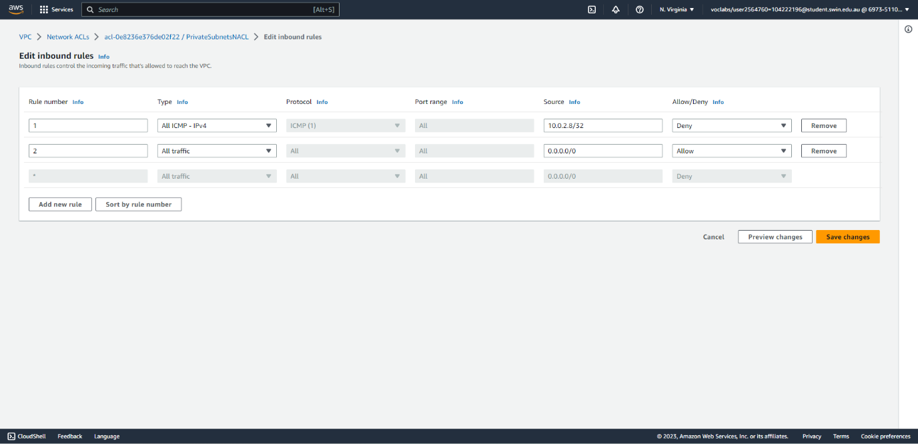



Fig. 51: Specify the inbound rules for the NACL such that ICMP traffic from 10.0.2.8/32 (the private IP address of the Dev server) is denied.

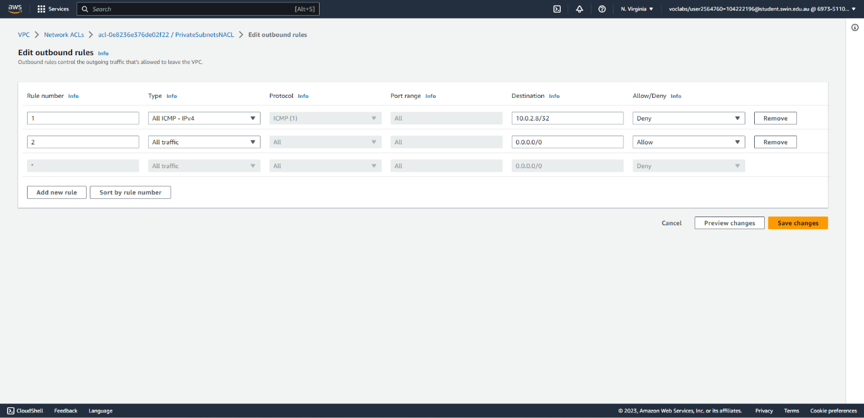



Fig. 52: Specify the outbound rules for the NACL such that ICMP traffic from 10.0.2.8/32 (the private IP address of the Dev server) is denied.

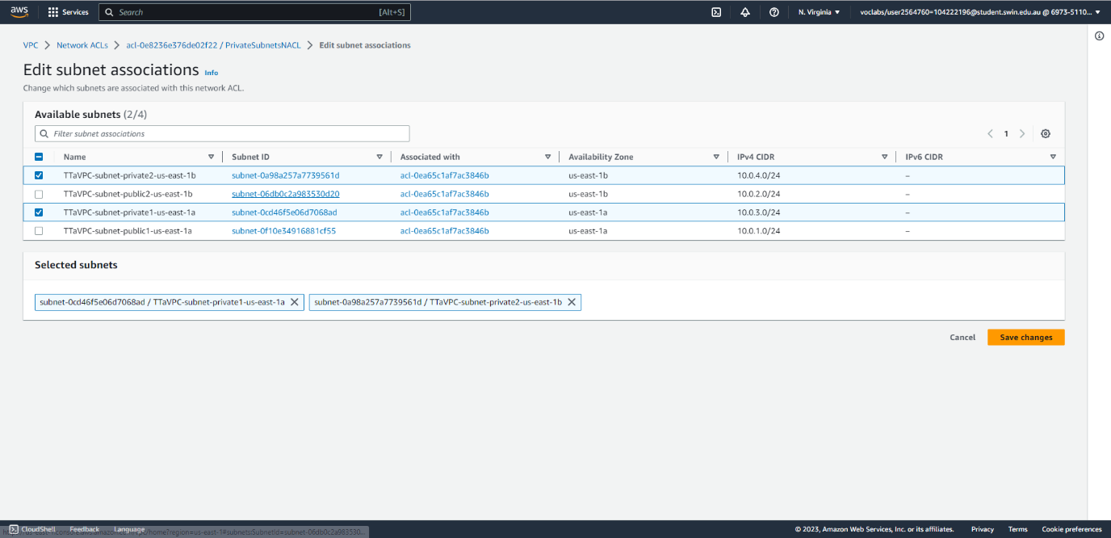

Fig. 53: Associate both private subnets with the NACL.

C – Complete the bucket policy

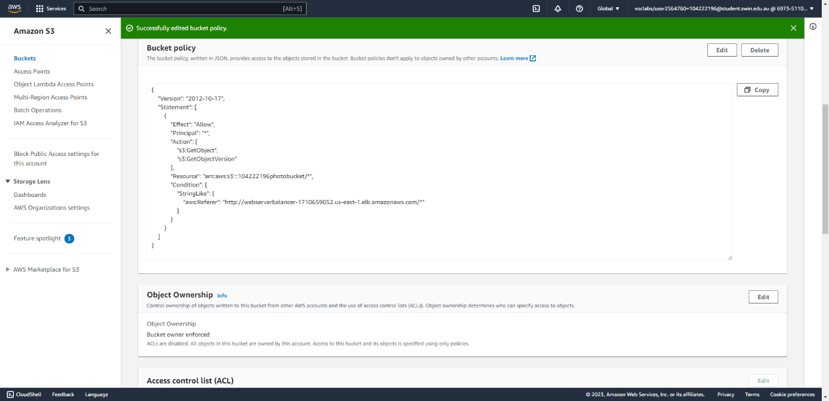



Fig. 54: Configure the S3 bucket policy so that images are only accessible through the photo album website (which is available through the load balancer.)

VIII – Final result

This section shows the final webpage after everything has been correctly configured.

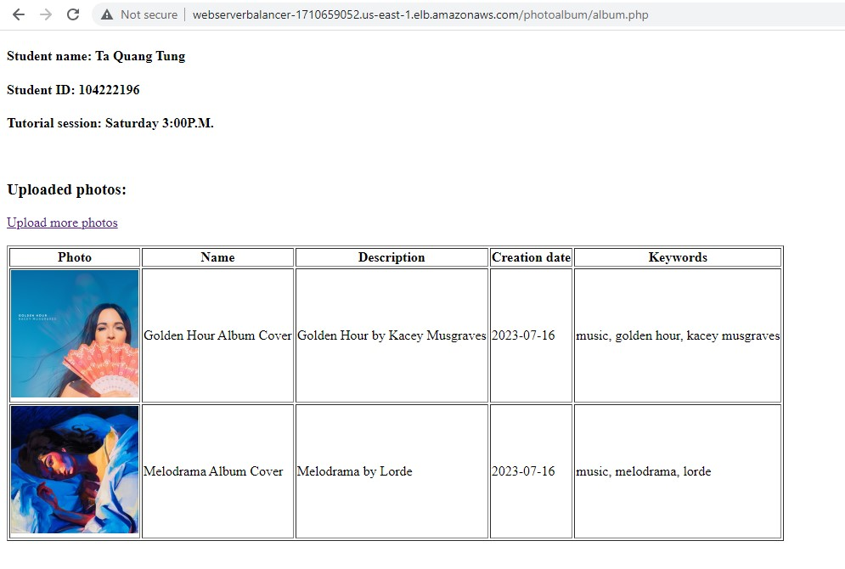

Fig. 55: After uploading two photos, they are correctly shown on the web page.

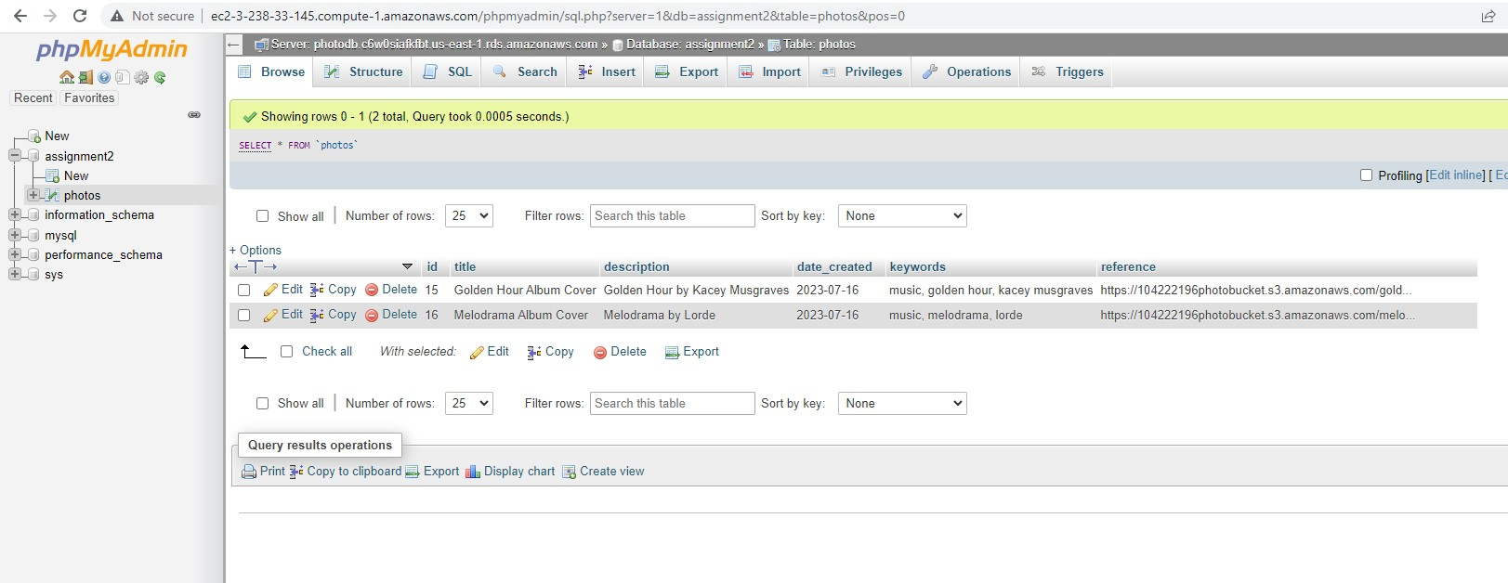

Fig. 56: The photo metadata is correctly stored in the database.

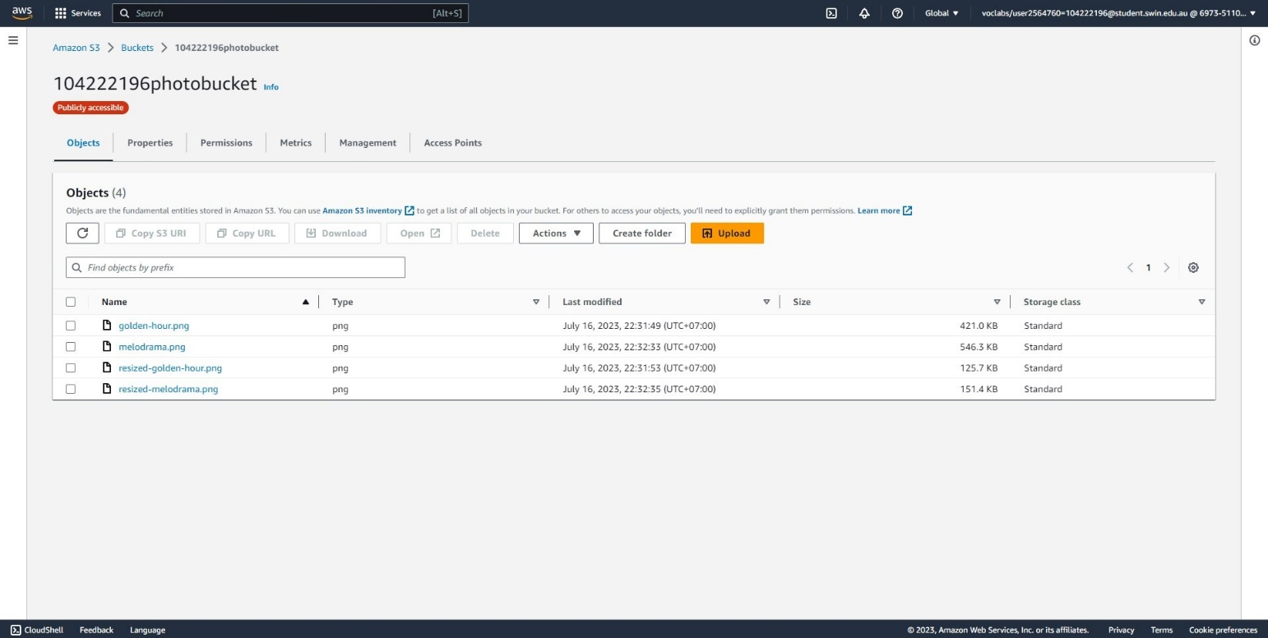

Fig. 57: The photos and their resized versions are correctly added to the S3 bucket.